1) SJF(non-preemptive)

#include <stdio.h>

#include <stdlib.h>

// Process structure

struct Process {

int pid; // Process ID

int burst_time; // Burst time

int arrival_time; // Arrival time

};

// Function to perform SJF scheduling (non-preemptive)

void sjf_non_preemptive(struct Process *processes, int n) {

int total_waiting_time = 0, total_turnaround_time = 0;

int completion_time[n], turnaround_time[n], waiting_time[n];

// Sort processes based on burst time

for (int i = 0; i < n - 1; i++) {

for (int j = 0; j < n - i - 1; j++) {

if (processes[j].burst_time > processes[j + 1].burst_time) {

struct Process temp = processes[j];

processes[j] = processes[j + 1];

processes[j + 1] = temp;

}

}

}

completion_time[0] = processes[0].burst_time;

turnaround_time[0] = completion_time[0] - processes[0].arrival_time;

waiting_time[0] = turnaround_time[0] - processes[0].burst_time;

total_waiting_time += waiting_time[0];

total_turnaround_time += turnaround_time[0];

for (int i = 1; i < n; i++) {

completion_time[i] = completion_time[i - 1] + processes[i].burst_time;

turnaround_time[i] = completion_time[i] - processes[i].arrival_time;

waiting_time[i] = turnaround_time[i] - processes[i].burst_time;

total_waiting_time += waiting_time[i];

total_turnaround_time += turnaround_time[i];

}

// Print result

printf("Process\tBurst Time\tArrival Time\tCompletion Time\tWaiting Time\tTurnaround Time\n");

for (int i = 0; i < n; i++) {

printf("%d\t%d\t\t%d\t\t%d\t\t%d\t\t%d\n", processes[i].pid, processes[i].burst_time,

processes[i].arrival_time, completion_time[i], waiting_time[i], turnaround_time[i]);

}

// Print average waiting time and average turnaround time

printf("Average Waiting Time: %.2f\n", (float)total_waiting_time / n);

printf("Average Turnaround Time: %.2f\n", (float)total_turnaround_time / n);

}

int main() {

int n;

printf("Enter the number of processes: ");

scanf("%d", &n);

struct Process processes[n];

for (int i = 0; i < n; i++) {

printf("Enter arrival time and burst time for process %d: ", i + 1);

scanf("%d %d", &processes[i].arrival_time, &processes[i].burst_time);

processes[i].pid = i + 1;

}

printf("\nSJF (Non-preemptive) Scheduling:\n");

sjf_non_preemptive(processes, n);

return 0;

}

Output

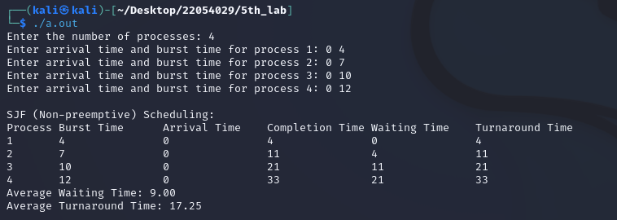

2) SJF (preemptive)

#include <stdio.h>

#include <stdlib.h>

#include <limits.h>

// Process structure

struct Process {

int pid; // Process ID

int burst_time; // Burst time

int remaining_time; // Remaining burst time

int arrival_time; // Arrival time

};

// Function to perform Preemptive SJF scheduling

void sjf_preemptive(struct Process *processes, int n) {

int current_time = 0, completed = 0;

int total_waiting_time = 0, total_turnaround_time = 0;

int waiting_time[n], turnaround_time[n];

// Initialize remaining time and waiting time

for (int i = 0; i < n; i++) {

processes[i].remaining_time = processes[i].burst_time;

waiting_time[i] = 0;

turnaround_time[i] = 0;

}

// Schedule processes until all are completed

while (completed != n) {

int min_remaining_time = INT_MAX;

int min_remaining_time_index = -1;

// Find process with minimum remaining time

for (int i = 0; i < n; i++) {

if (processes[i].arrival_time <= current_time && processes[i].remaining_time < min_remaining_time && processes[i].remaining_time > 0) {

min_remaining_time = processes[i].remaining_time;

min_remaining_time_index = i;

}

}

// If no process is found, increment current time

if (min_remaining_time_index == -1) {

current_time++;

continue;

}

// Execute the process for 1 unit of time

processes[min_remaining_time_index].remaining_time--;

current_time++;

// If a process is completed

if (processes[min_remaining_time_index].remaining_time == 0) {

completed++;

int completion_time = current_time;

waiting_time[min_remaining_time_index] = completion_time - processes[min_remaining_time_index].burst_time - processes[min_remaining_time_index].arrival_time;

turnaround_time[min_remaining_time_index] = completion_time - processes[min_remaining_time_index].arrival_time;

total_waiting_time += waiting_time[min_remaining_time_index];

total_turnaround_time += turnaround_time[min_remaining_time_index];

}

}

// Print result

printf("Process\tBurst Time\tArrival Time\tWaiting Time\tTurnaround Time\n");

for (int i = 0; i < n; i++) {

printf("%d\t%d\t\t%d\t\t%d\t\t%d\n", processes[i].pid, processes[i].burst_time,

processes[i].arrival_time, waiting_time[i], turnaround_time[i]);

}

// Print average waiting time and average turnaround time

printf("Average Waiting Time: %.2f\n", (float)total_waiting_time / n);

printf("Average Turnaround Time: %.2f\n", (float)total_turnaround_time / n);

}

int main() {

int n;

printf("Enter the number of processes: ");

scanf("%d", &n);

struct Process processes[n];

for (int i = 0; i < n; i++) {

printf("Enter arrival time and burst time for process %d: ", i + 1);

scanf("%d %d", &processes[i].arrival_time, &processes[i].burst_time);

processes[i].pid = i + 1;

}

printf("\nSJF (Preemptive) Scheduling:\n");

sjf_preemptive(processes, n);

return 0;

}

Output

